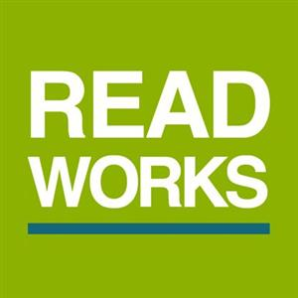  Read Works  Read an article and answer questions  https://www.readworks.org/ | 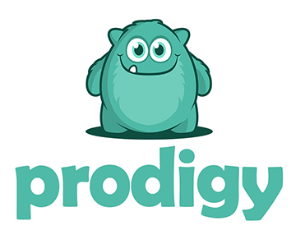  Prodigy  Play standard based math games and pass the time learning something new.  https://www.prodigygame.com/ | 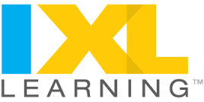  IXL  ELA, Math, Science, Social Studies, and Spanish  https://www.ixl.com | 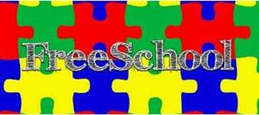  Free School  A safe and friendly place to expose children to famous art, classical music, children's literature, and natural science in an age-appropriate and kid-accessible way.
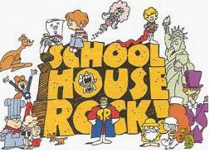  School House Rock  Description: Animated musical educational short films. The themes covered included grammar, science, economics, history, mathematics, and civics. | 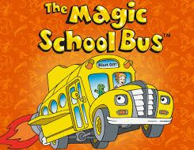  The Magic School Bus  Description: Ms. Frizzle takes her class on a virutal bus ride; taking field trips to multiple places. | 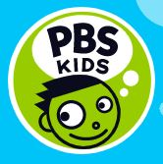  PBS Kids  Description: Curriculum-based media to support children with learning knowledge and critical thinking skills while empowering their imagination and curiosity of the world. |   Storyline Online  Description: Videos of famous actors reading children's books.
  Exploratorium  Description: Not just an museum; it's an ongoing exploration of science, art, and human perception. |   NASA Space Place  Description: Engaging website with science information, interactive games, videos, etc. |   Smithsonian Museum Online  Description: Discover, create, remix, and share museum artifacts. |   Google Earth  3D representation of the Earth (globe), based primarily on satelite imagery.
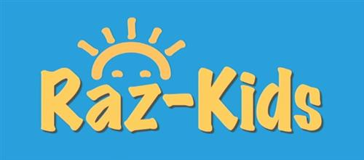  RAZ-KIDS  Kids A-Z is a kid-friendly learning portal where students go to access all their eLearning materials in an interactive online environment. | 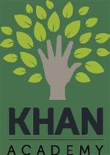  KHAN  Khan Academy is a free resource for students, teachers, and parents. We offer free lessons in math, science and humanities from kindergarten | 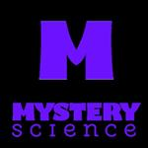  Mystery Science  Hands –on learning experience in science and engineering. | 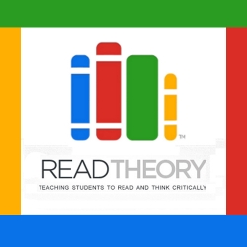  Reading comprehension exercises — online, free, personalized & adaptive. Fits K-12, ESL and adult students. Easily track the progress of the entire class.
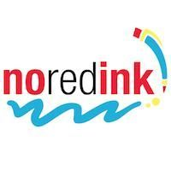  NoRedInk is an adaptive learning tool that helps students improve their grammar and writing skills. | 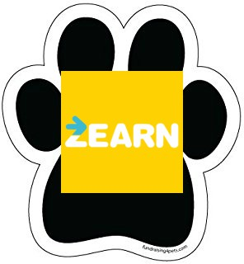  Zearn  The only curriculum top-rated by EdReports that unites hands-on instruction and immersive digital learning. Aligned to Eureka Math / EngageNY.

